CLUSTERING OF COUNTRIES
By: - Shubhang Singh
Objective:
HELP International is an international humanitarian NGO that is committed to fighting poverty and providing the people of backward countries with basic amenities and relief during the time of disasters and natural calamities. It runs a lot of operational projects from time to time along with advocacy drives to raise awareness as well as for funding purposes.

Problem Statement:
During the recent funding programs, NGO have been able to raise around $ 10 million. As an analyst, we have to come up with the countries list that are in the direst need of aid.

Analysis Approach:
•Data Collection and Data Cleaning:
Importing the data then cleaning it, checking if there are any null values. We found out that some columns were in %of gdpp form so corrected them using the correct formulas.
•Visualizing data:
We detected outliers by visualizing the data, outliers were treated according to our problem statement. We also found out that some Variables are highly corelated to each other.
•Outliers Detection and treatment:
There were outliers in almost every column. Some outliers like in gdpp column for example, have outliers on high end of spectrum which we can remove safely because high gdpp countries won’t need urgent aid. For this analysis we capped the gdpp column at .95 quantile at upper end and .1 quantile at lower end. We did not capped other variable because that would affect our analysis for finding poorest countries with high child mortality.
•Scaling data:
Standardizing all the continuous variables.

•Hopkins test:
To check if data has tendency to form clusters.
•Kmeans Clustering:
Identifying the “k” through silhouette analysis and elbow curve. Then forming the cluster on scaled data, the adding the cluster id on original data for better interpretation of data. And visualizing the clusters.

Kmeans Clustering
We can see in silhouette analysis that highest peak is at 2, but 2 is never a good number for clustering, on the other hand elbow curve has elbow at 3. Therefore, we choose 3 as the number of clusters.
When we go through Kmeans Cluster Profiling, we see that cluster 1 has very low income and gdpp but very high child_mort, therefore this cluster will be our prime focus.
Top 10 Countries obtained from K-Means Clustering in dire need of Aid, sorted by child mortality as decreasing order and income and Gdpp as increasing order are as follows:

Hierarchical Clustering
We first went for single linkage, which resulted in a poor formation of clusters hence we went for complete linking which resulted in a much defined and structured clusters.
As a result, we see that Cluster 0 have low income, low gdpp and high child_mort rate which makes it the target cluster.

Top 10 countries obtained from hierarchical clustering in dire need, sorted by child mortality in decreasing order and income and gdppin increasing order.

Summary
We got same top 10 countries from both hierarchical and k-means model that are in dire need of Aid.
Following are the countries name requiring aid.
1.Sierra Leone
2.Central African Republic
3.Haiti
4.Chad
5.Mali
6.Nigeria
7.Niger
8.Angola
9.Congo, Dem. Rep.
10.Burkina Faso

Clustering Questions
Ans 1) k-means is method of cluster analysis using a pre-specified no. of clusters. It requires advance knowledge of ‘K’.
Hierarchical clustering also known as hierarchical cluster analysis (HCA) is also a method of cluster analysis which seeks to build a hierarchy of clusters without having fixed number of clusters.
Main differences between K means and Hierarchical Clustering are:
k-means Clustering | Hierarchical Clustering
k-means, using a pre-specified number of clusters, the method assigns records to each cluster to find the mutually exclusive cluster of spherical shape based on distance. | Hierarchical methods can be either divisive or agglomerative.
K Means clustering needed advance knowledge of K i.e., no. of clusters one wants to divide your data. | In hierarchical clustering one can stop at any number of clusters, one finds appropriate by interpreting the dendrogram.
One can use median or mean as a cluster center to represent each cluster. | Agglomerative methods begin with ‘n’ clusters and sequentially combine similar clusters until only one cluster is obtained.
Methods used are normally less computationally intensive and are suited with exceptionally large datasets. | Divisive methods work in the opposite direction, beginning with one cluster that includes all the records and Hierarchical methods are especially useful when the target is to arrange the clusters into a natural hierarchy.
In K Means clustering, since one start with random choice of clusters, the results produced by running the algorithm many times may differ. | In Hierarchical Clustering, results are reproducible in Hierarchical clustering

Ans 2) Steps in Kmeans Clustering:
Step 1: Choose the number of clusters k
The first step in k-means is to pick the number of clusters, k.

Step 2: Select k random points from the data as centroids
Next, we randomly select the centroid for each cluster. Let’s say we want to have 2 clusters, so k is equal to 2 here. We then randomly select the centroid:
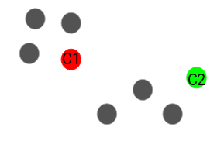
Here, the red and green circles represent the centroid for these clusters.

Step 3: Assign all the points to the closest cluster centroid
Once we have initialized the centroids, we assign each point to the closest cluster centroid:
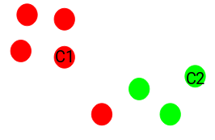
Here you can see that the points which are closer to the red point are assigned to the red cluster whereas the points which are closer to the green point are assigned to the green cluster.

Step 4: Recompute the centroids of newly formed clusters
Now, once we have assigned all of the points to either cluster, the next step is to compute the centroids of newly formed clusters:
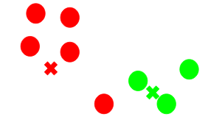
Here, the red and green crosses are the new centroids.

Step 5: Repeat steps 3 and 4
We then repeat steps 3 and 4:
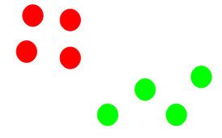
Stopping Criteria for K-Means Clustering
There are essentially three stopping criteria that can be adopted to stop the K-means algorithm:
- Centroids of newly formed clusters do not change.
- Points remain in the same cluster.
- Maximum number of iterations are reached.
We can stop the algorithm if the centroids of newly formed clusters are not changing. Even after multiple iterations, if we are getting the same centroids for all the clusters, we can say that the algorithm is not learning any new pattern and it is a sign to stop the training.
Another clear sign that we should stop the training process if the points remain in the same cluster even after training the algorithm for multiple iterations.
Finally, we can stop the training if the maximum number of iterations is reached. Suppose if we have set the number of iterations as 100. The process will repeat for 100 iterations before stopping.

Ans 3) The methods for determining optimal number of clusters in Kmeans clustering are:
- The Elbow Method
- The Silhouette Method
The Elbow Method
This is probably the most well-known method for determining the optimal number of clusters. It is also a bit naive in its approach.
Calculate the Within-Cluster-Sum of Squared Errors (WSS) for different values of k and choose the k for which WSS becomes first starts to diminish. In the plot of WSS-versus-k, this is visible as an elbow.
Within-Cluster-Sum of Squared Errors sounds a bit complex. Let’s break it down:
The Squared Error for each point is the square of the distance of the point from its representation i.e., its predicted cluster center.
The WSS score is the sum of these Squared Errors for all the points.
Any distance metric like the Euclidean Distance or the Manhattan Distance can be used.
The Silhouette Method
The silhouette value measures how similar a point is to its own cluster (cohesion) compared to other clusters (separation).
Source: Wikipedia
The range of the Silhouette value is between +1 and -1. A high value is desirable and indicates that the point is placed in the correct cluster. If many points have a negative Silhouette value, it may indicate that we have created too many or too few clusters.
The Silhouette Value s(i) for each data point i is defined as follows:
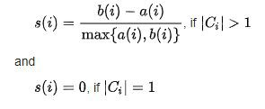
Source: Wikipedia
Note: s(i) is defined to be equal to zero if i is the only point in the cluster. This is to prevent the number of clusters from increasing significantly with many single-point clusters.
Here, a(i) is the measure of similarity of the point i to its own cluster. It is measured as the average distance of i from other points in the cluster.

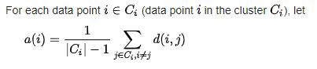
Source: Wikipedia
Similarly, b(i) is the measure of dissimilarity of i from points in other clusters.

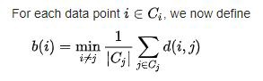
Source: Wikipedia
d(i, j) is the distance between points i and j. Generally, Euclidean Distance is used as the distance metric.
The Silhouette score can be easily calculated in Python using the metrics module of the sklearn library.
The Elbow Method is more of a decision rule, while the Silhouette is a metric used for validation while clustering. Thus, it can be used in combination with the Elbow Method.
Therefore, the Elbow Method and the Silhouette Method are not alternatives to each other for finding the optimal K. Rather they are tools to be used together for a more confident decision.
Along with this it is very important for us to be fluent with the domain of the dataset we are dealing with because even after applying these methods it is always important to take the view of the client to cross check if we are doing the segmentation as per the business understanding.

Ans 4) It depends on your data.
If you have attributes with a well-defined meaning. Say, latitude and longitude, then you should not scale your data, because this will cause distortion. (K-means might be a bad choice, too - you need something that can handle lat/lon naturally)
If you have mixed numerical data, where each attribute is something entirely different (say, shoe size and weight), has different units attached (lb, tons, m, kg ...) then these values aren't really comparable anyway; z-standardizing them is a best-practice to give equal weight to them.
If you have binary values, discrete attributes or categorial attributes, stay away from k-means. K-means needs to compute means, and the mean value is not meaningful on this kind of data.

Ans 5) Types of linkage in Hierarchical Clustering are:
The process of Hierarchical Clustering involves either clustering sub-clusters (data points in the first iteration) into larger clusters in a bottom-up manner or dividing a larger cluster into smaller sub-clusters in a top-down manner. During both the types of hierarchical clustering, the distance between two sub-clusters needs to be computed. The different types of linkages describe the different approaches to measure the distance between two sub-clusters of data points. The different types of linkages are: -
1. Single Linkage: For two clusters R and S, the single linkage returns the minimum distance between two points i and j such that i belongs to R and j belongs to S.
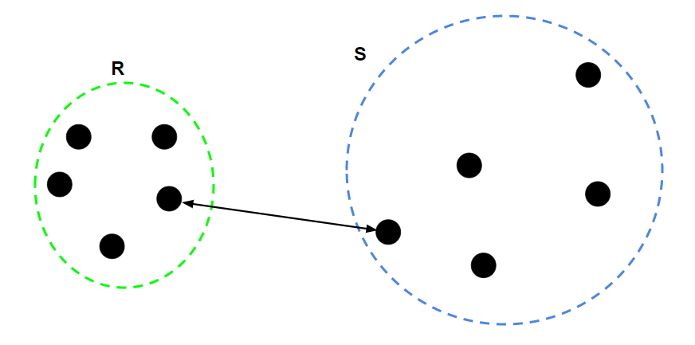

2. Complete Linkage: For two clusters R and S, the single linkage returns the maximum distance between two points i and j such that i belongs to R and j belongs to S.

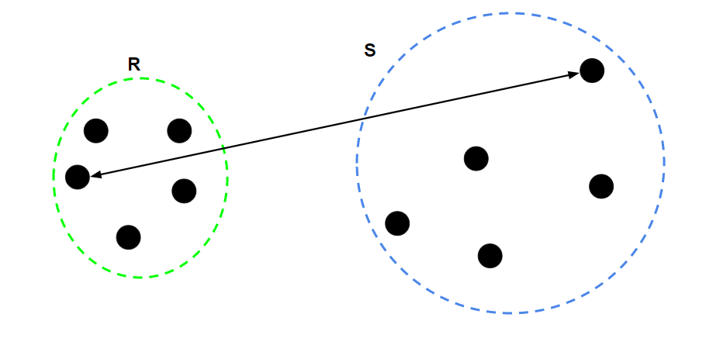

3. Average Linkage: For two clusters R and S, first for the distance between any data-point i in R and any data-point j in S and then the arithmetic mean of these distances are calculated. Average Linkage returns this value of the arithmetic mean.
